BCA III Semester

**New Summit College**



**Probability & Statistics**

*(BCA-Department of Humanities)*

**Title: LAB reports on STATISTICS AND PROBABILITY**

**Submitted by: Submitted to:**

**Name:** Ganesh Neupane**Instructor:** Murari Karki

**Roll No.:** 10 **Date of Submission:** 24 January 2020

**Semester:** Third

1. **PROBLEM COMPUTE MEAN, MODE, MEDIAN, S.D, C.V & Q3**

|  |  |  |  |  |  |
| --- | --- | --- | --- | --- | --- |
| C.I | 0-10 | 10-20 | 20-30 | 30-40 | 40-50 |
| freq. | 5 | 10 | 20 | 15 | 5 |

**WORKING EXPRESSION:**

Here, we use

Mean = Σx / N

Median(Md)= l+(N/2-c.f/f)*i

Mode (Mo)= l+(f1-f0)/2f1-f0-f2)*i

Standard Deviation(S.D)= sqrt(fx2/N-(fx/N)2

Coefficient of Variance (C.V)= S.D/X-*100

Q3= l+(3N/4-c.f/f)*i

**CALCULATION:**

From excel we have,

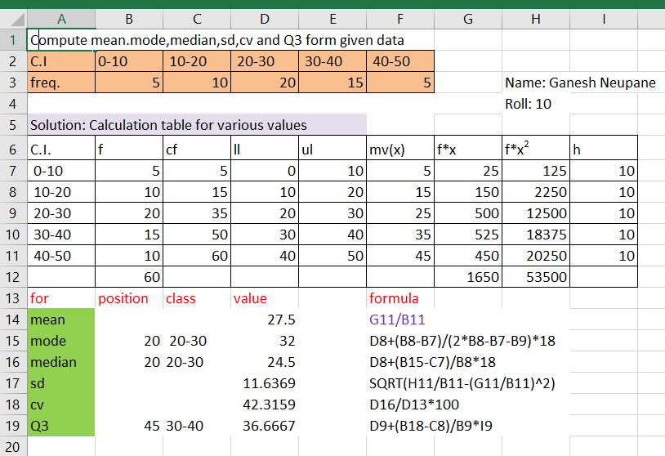

Mean=27.5

Median=24.5

Mode=32

S.D=11.63687

C.V=42.31588 &

Q3=36.66667

**CONCLUSION**:

From excel, We have mean=27.5, median=24.5, mode= 32, S.D=11.63687, CV=42.31588 & Q3 36.66667.

1. **PROBLEM COMPUTE CORRELATION COEFFICIENT FROM THE GIVEN DATA**

|  |  |  |  |  |  |  |
| --- | --- | --- | --- | --- | --- | --- |
| WEIGHT: | 45 | 35 | 42 | 71 | 65 | 82 |
| HEIGHT: | 55 | 45 | 45 | 62 | 60 | 62 |

**WORKING EXPRESSION:**

Here, we use

CORRELATION COEFFICIENT=CORREL(B5:B11,C5:C11)

**CALCULATION**:

From excel we have,

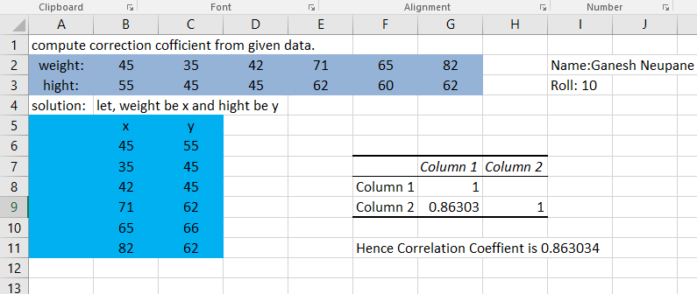

Correlation Coefficient= 0.863034

**CONCLUSION:**

Hence we have got Correlation Coefficient of two values is 0.863034

Using excel sheet.

**PROBLEM COMPUTE DIFFERENT PROBABILITY**

|  |  |  |  |  |
| --- | --- | --- | --- | --- |
| A fair coins are tossed, Compute the probability of getting | | | | |
| i) four heads | ii) no heads | |  |  |
| iii) at least two heads | iv) at most three heads | | |  |
| v)not more than two heads | | vi)not less than four heads | | |

**WORKING EXPRESSION:**

Here, we use

**BINOMDIST**(x, n, p, FALSE) &

**BINOMDIST**(x, n, p, TRUE)

In case of greater or smaller

1-BINOMDIST(x, n, p, TRUE or FALSE)

**CALCULATION**:

From excel, we have

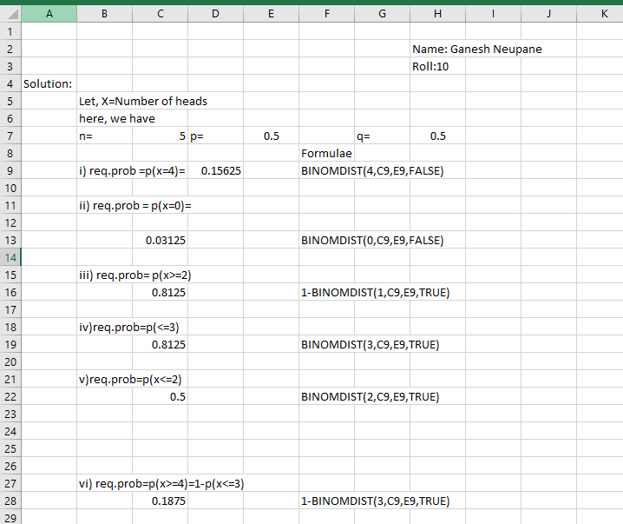

1. Required prob. = p(x=4)= 0.15625
2. Required prob. = p(x=0)= 0.03125
3. Required prob. = p(x>=2)

= 1-p(X<=1) =0.8125

1. Required prob. = p(x<=3)=N*p(x<=2)= 0.8125
2. Required prob.= p(x<=2) =0.5
3. Required prob. = p(X>=4)

=1-p(X<=3) = 0.8125

**CONCLUSION**:

Hence we have got different required probability using excel sheet.

**PROBLEM TO COMPUTE BINOMIAL DISTRIBUTION**

Fit the binomial distribution:

|  |  |  |  |  |  |  |
| --- | --- | --- | --- | --- | --- | --- |
| x | 0 | 1 | 2 | 3 | 4 | 5 |
| f | 6 | 12 | 35 | 45 | 24 | 6 |

**WORKING EXPRESSION:**

Here, we use

Expected Frequencies= N* BINOMDIST (x, n, mean,0)

Mean=n*p

**CALCULATION**:

From excel, we have

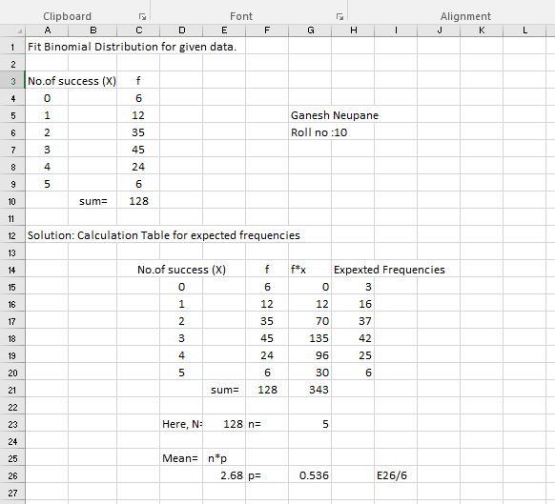

Expected Frequencies= 3,16,37,42,25&6 for different six given data.

**CONCLUSION:** Hence we have got different expected frequencies using binomial distribution.

**PROBLEM TO COMPUTE DIFFERENT PROBABILITY**

|  |  |  |  |  |  |  |  |  |  |  |  |
| --- | --- | --- | --- | --- | --- | --- | --- | --- | --- | --- | --- |
| A survey was conducted in five 512 families with four children each, Compute the expected number | | | | | | | | | | | |
| of families with | | | |  |  |  |  |  |  |  |  |
| i)two boys | iv) at least 1 bot |  |
| ii)three boys | v)less than 3 boys |  |
| iii)at most two boys | vi)not more than 3 boys | |

WORKING EXPRESSION:

Here, we use

Probability = N*(**BINOMDIST**(x, n, p, FALSE) &

N\***BINOMDIST**(x, n, p, TRUE)

**CALCULATION:**

From excel, we have

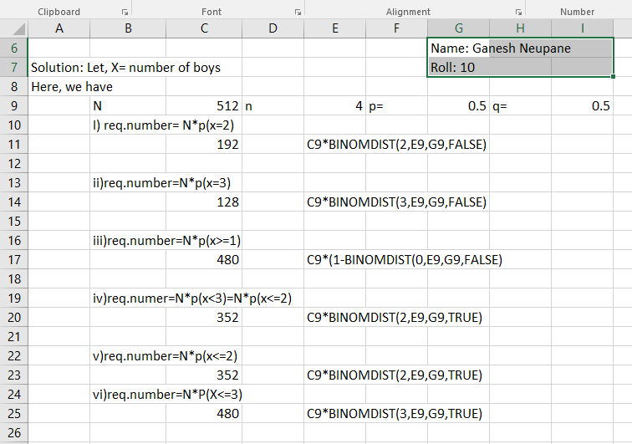

1. Required Number= N*p(x=2)= 192
2. Required Number= N*p(x=3)= 128
3. Required Number= N*p(x>=1)=480
4. Required Number= N*p(x<3)=N*p(x<=2)=352
5. Required Number= N*p(x<=2)=352
6. Required Number= N*P(X<=3)=480

**CONCLUSION:**

Hence, we ‘ve got different probability of number using BINOMDIST expression.

PROBLEM TO COMPUTE NORMAL DISTRIBUTION

Compute,

**a) probability that salary of a randomly selected employee lies**

i) below 6000

ii)between 4000 to 6000

iii) Between 6000-7000

**b) Number of employees whose salary is**

i) More than 6000

ii) between 4800 to 5200

iii) less than 5400

**WORKING EXPRESSION**:

Here, we use

Probability = N\***BINOMDIST**(x, n, p, TRUE)

**CALCULATION:**

From excel, we have

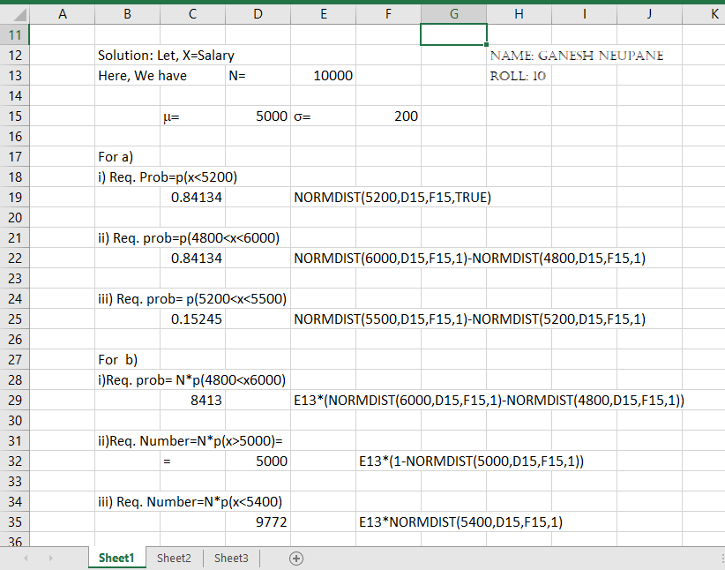

For a)

i) Required prob. = p(x<5200)= 0.841345

ii) Req. prob=p(4800<x<6000)= 0.841344

iii) Req. prob= p(5200<x<5500)= 0.152446

For b)

i)Req. Number = N*p(4800<x6000)= 8413

ii)Req. Number=N*p(x>5000)= 5000

iii) Req. Number=N*p(x<5400)= 9772

**CONCLUSION:**

Hence, we ‘ve got different probability of number using BINOMDIST expression.

**PROBLEM TO COMPUTE POISSON DISTRIBUTION**

Out of 100 items the distribution of defective are shown below. Fit poisson distribution to given data.

|  |  |  |
| --- | --- | --- |
| No. of defects | no of defectives | |
| 0 | 60 |  |
| 1 | 25 |  |
| 2 | 12 |  |
| 3 | 8 |  |
| 4 | 3 |  |
| 5 | 1 |  |

**WORKING EXPRESSION:**

Here, we use

**CALCULATION:**

From excel, we have

